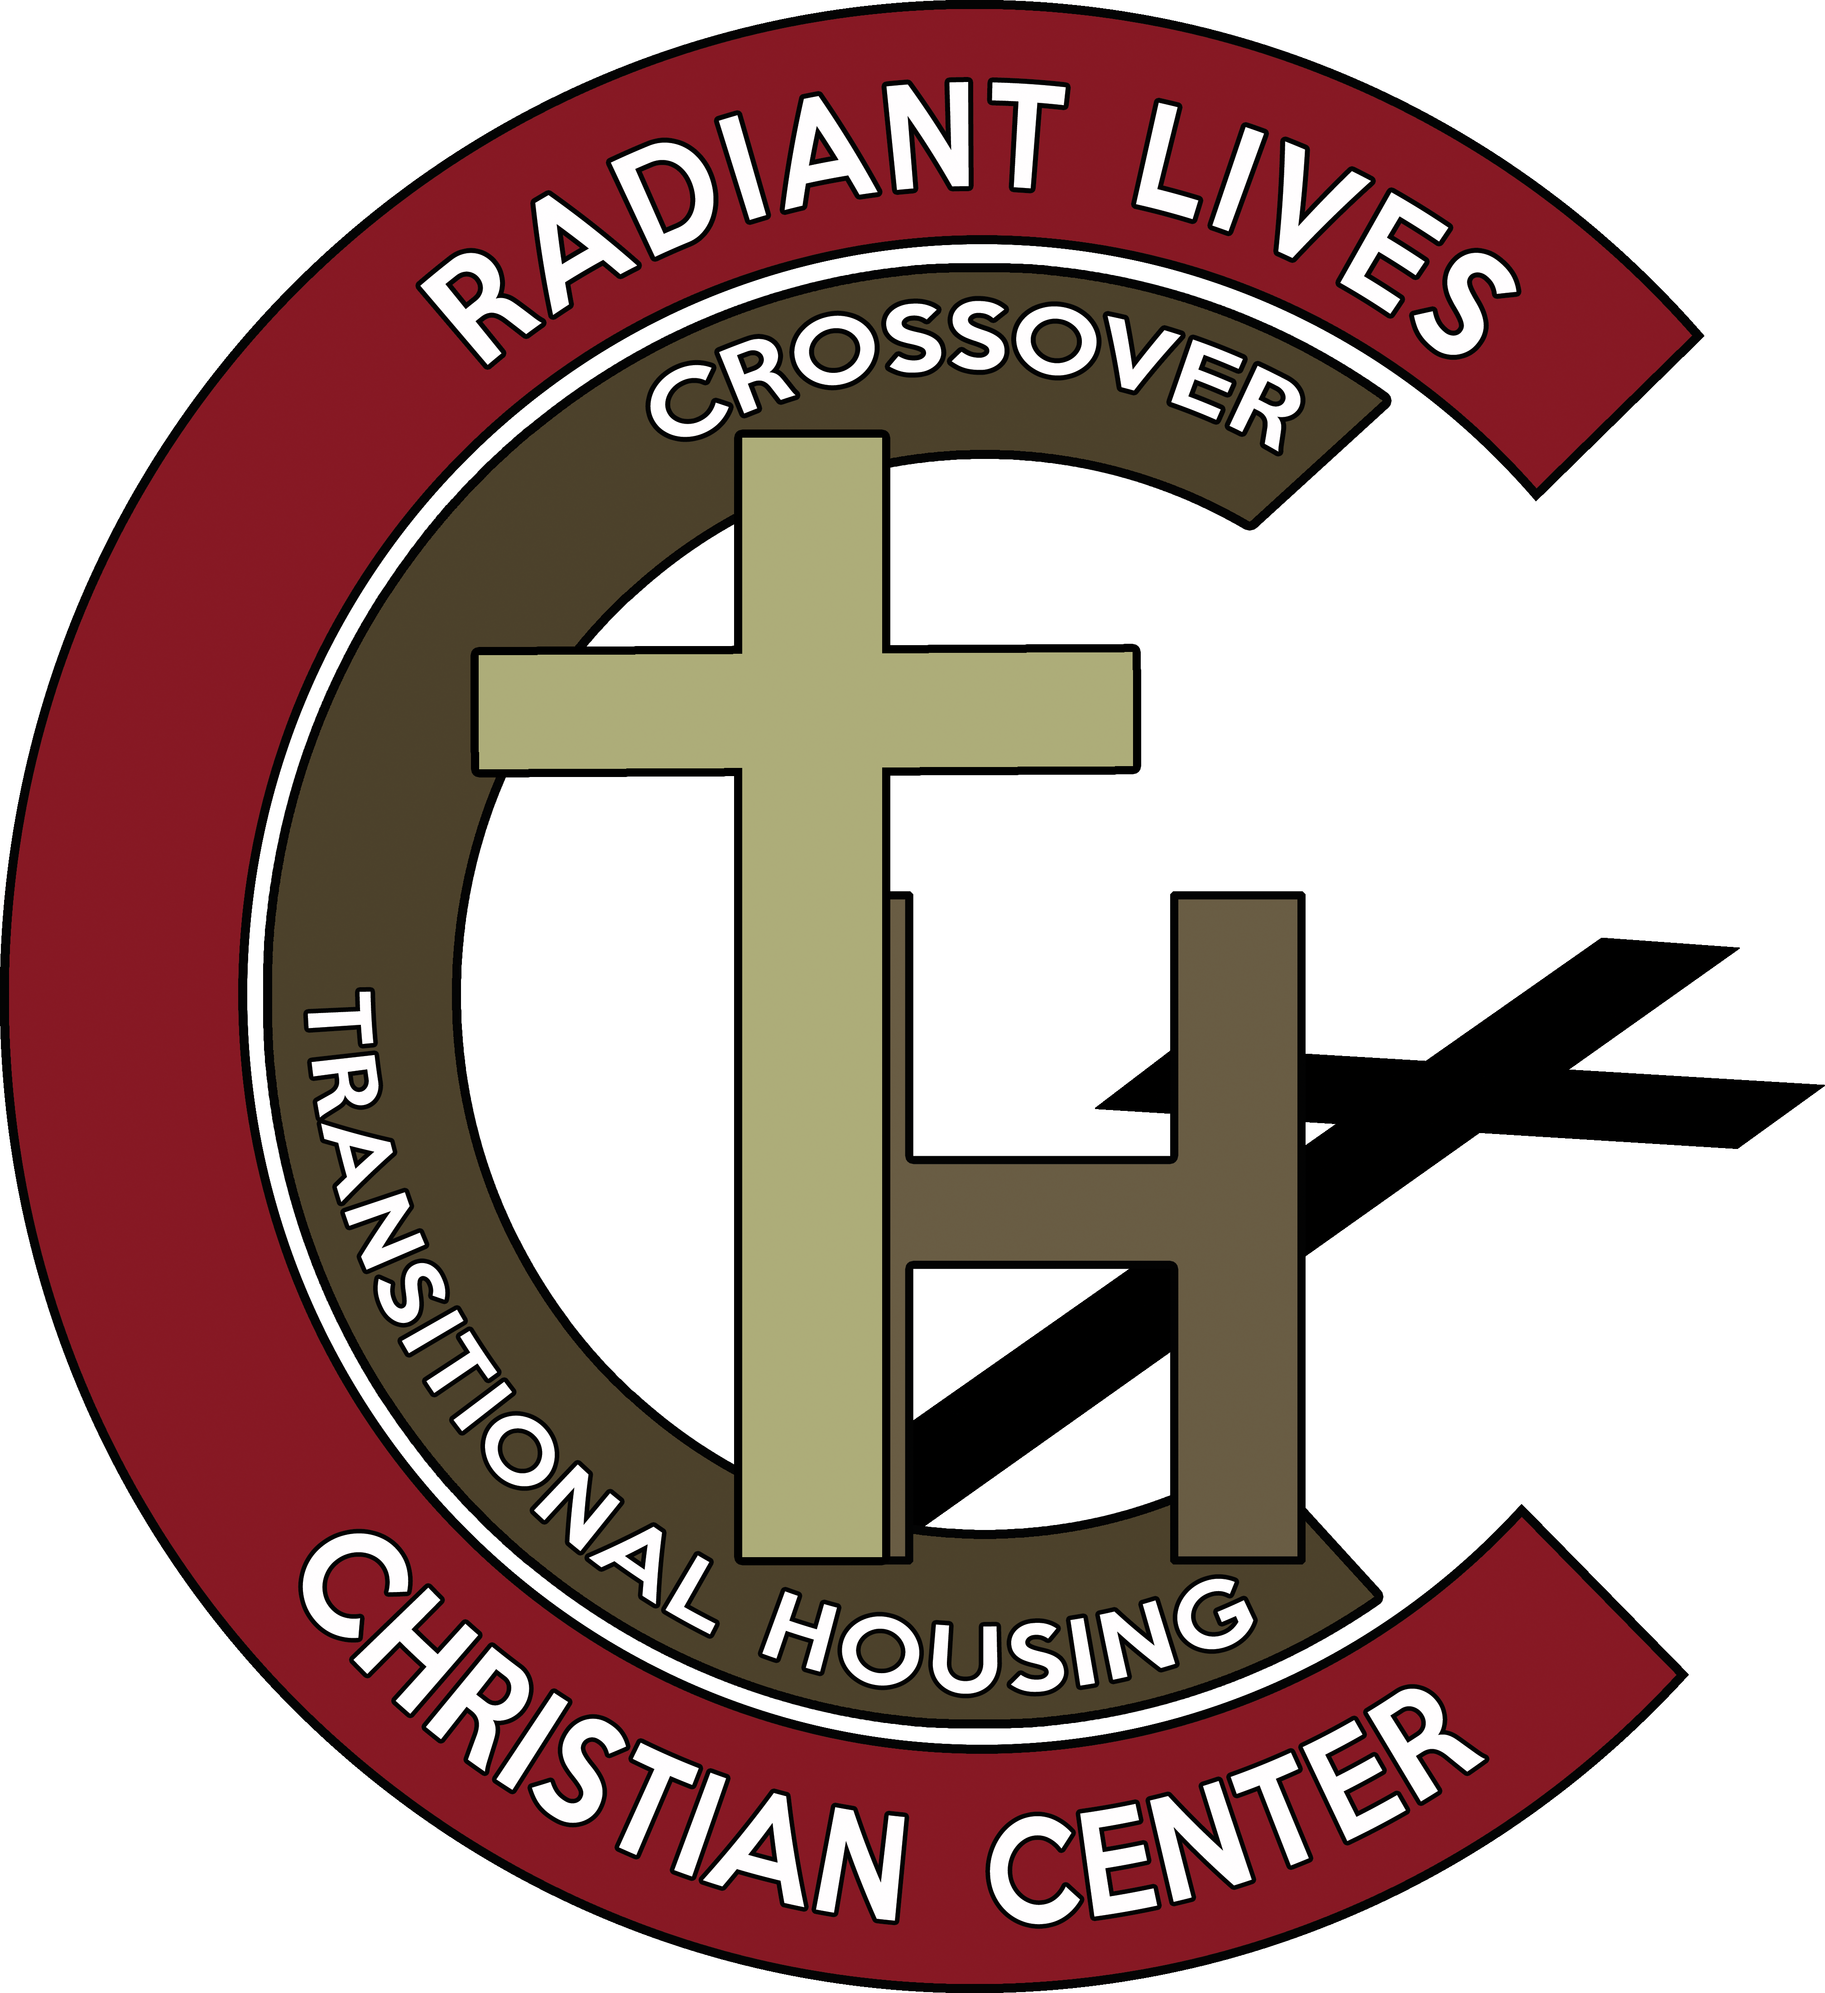
Crossover Transitional Housing
Radiant Lives Christian Center

RESIDENT CONTRACT

Mailing address:

PO Box 103, Holden, Mo. 64040
Office Phone: #816.560.1350  Founders: Tim & Cindy Cox

or email to – radiantlives98@gmail.com

Resident Contract
Crossover Transitional Housing is not an affordable housing program, but rather a transition program, providing comprehensive services to help residents’ transition into law-abiding, productive citizens and neighbors. For this reason, conditions for participation in the program may extend to social, financial, psychological, emotional and physical aspects of the life of program participants. This is a Christ-centered program. Residents will be required to attend Radiant Lives Christian Center Church, a Bible teaching, Bible believing church that teaches Jesus as Lord according to the Word of God. Devotions will be provided at the house in the mornings and personal counseling will be available upon request. Residents will be required to have a one-on-one session with a counselor of Crossover Transitional Housing, once per month.

Refusal to abide by the written rules and policies or verbal directives of Crossover Transitional Housing staff, may result in the resident’s immediate dismissal and removal from Crossover Transitional Housing.

Rules and Policies
Alcohol and Drug Policy: Alcohol and illegal drug use is not tolerated. Residents will be randomly drug tested. Residents must notify Crossover Transitional Housing staff of any prescriptions and can be discharged for not taking medications as prescribed. Residents must also notify Crossover Transitional Housing staff when they suspect alcohol/drug use of another resident. Residents are subject to a substance use test at any time a staff member requests. Failure to pass a test will result in disciplinary action and/or discharge from the house program.

Curfew Policy: Phase #1 residents have a 6:00pm curfew seven days a week; Phase #2 and Phase #3 residents have a 10:00pm curfew Sunday–Saturday. Overnight passes will be granted on rare occasions through an Overnight Pass Application, which must be submitted at least ten days in advance to the house manager. The house manager regulates all three phases. Phase #1 begins as soon as a resident enters the program. Residents are not released from a phase until directly notified by the house manager.

Profanity, Pornography, and Sexual Contact Policy: Residents must refrain from the use of profanity, must not view or be in possession of pornographic material, and are prohibited from sexual contact of any kind while in the Crossover Transitional Housing program.

Chore Policy: All residents are required to keep their personal living area, in the house, neat and clean. Residents will also be assigned daily, weekly and monthly chores. Residents will be required to make their own bed in the morning (every morning); not doing so could result in a mark against them. There is a 3-strike policy for discharge from the house program. Bed making and other related house-cleanliness and self-cleanliness chores, take 3 marks to equal 1 strike on the 3-strike scale.
Employment Policy: Residents must be employed, or actively and aggressively seeking employment. Residents prohibited from employment due to health or disabilities are excused from the employment policy.

Program Fee/Community Service Policy: Residents will pay an $80/week housing fee. The money will go to the Crossover Transitional Housing to help pay their portion of: utilities, food and upkeep of the house and property. Residents who do not have income are required to perform 20 hours/week of community service in lieu of program fees. All residents, including those with disabilities, are required to perform 10 hours/week of community service (for the furthering of the ministry and/or the community). This can, and will include, any/all work needed at any of the ministry properties. Community service teaches how to give, as our Lord and Savior taught us to. Residents will have a 30-day grace period to find adequate employment. Upon a resident’s first paycheck (regardless of 30-day grace period), the resident will be required to start paying the $80/week housing fee. This is a 12-month program for residents to be back up on their feet and back functioning in society.

Visitor Policy: No visitors, except upon special request. Requests must be upon times and dates set by the house manager. ABSOLUTELY, NO OVERNIGHT VISITORS!

Unsupervised Leave: Residents must notify the house manager at least three days in advance, in writing, of any plans or activities, that would require them leaving Crossover Transitional Housing staff supervision; on/or off CTH/RLCC properties. (see Program Phases).

Relationship Policy: NO ROMANTIC RELATIONSHIPS during the 12-month program. This will lead to IMMEDIATE DISMISSAL/EVICTION/PROGRAM TERMINATION!!! Exceptions include, baby’s mother and wives.

Community Conduct Policy: Residents are required to conduct themselves in a respectful and appropriate manner throughout the community, knowing they are a reflection of CTH/RLCC at all times.

Illegal Activities Policy: Residents are prohibited from engaging in any illegal activity.

Miscellaneous Rules:
- Residents are not allowed to have pets on the CTH/RLCC premises.
- Games, pornography and other inappropriate computer use is prohibited, this includes inappropriate TV programs (shows).
- No lying down or sleeping in common areas.
- Residents are not allowed to adjust furnace/AC thermostat.
- Residents must adhere to the structure and expectations specific to their “Phase” in the program.

By signing below, I acknowledge, I have read and understand all the expectations listed above. I understand I can be discharged from the house for not complying with these expectations. I also understand this is not a complete list of everything that is expected as a resident of Crossover Transitional Housing. I am expected at all times, in and out of the house, to conduct myself in an appropriate and respectful manner.

_________________________________________________ _____________________________________________________ ___________________
Print Name Signature Date

_______________________   Crossover Transitional Housing Staff Use Only   _______________________

Resident Name: ________________________________________________________________________________________________________________
DOC #: ____________________
Admission Drug Screen: ____Yes ____No Results: _______________________________________________________________
House Interview: ____Yes ____No
Staff Review of Policies and Rules: ____Yes ____No
Additional Comments: _________________________________________________________________________________________________________
____________________________________________________________________________________________________________________________________
____________________________________________________________________________________________________________________________________
____________________________________________________________________________________________________________________________________
____________________________________________________________________________________________________________________________________

Face Sheet

Resident Name: ______________________________________________________________ DOC #: ________________________________
Date of Admission: _________________________________ Date of Discharge from DOC: _________________________________
Date of Birth: _______/_______/_________
Phone #: __________________________________________
Emergency Contact Name: ___________________________________________ Emergency Phone #: __________________________
Emergency Contact Name: ___________________________________________ Emergency Phone #: __________________________
Medication: Yes____ No____ List: _______________________________________________________________________________________
____________________________________________________________________________________________________________________________________
____________________________________________________________________________________________________________________________________
Reason for Incarceration: _____________________________________________________________________________________________________
____________________________________________________________________________________________________________________________________
____________________________________________________________________________________________________________________________________
____________________________________________________________________________________________________________________________________
____________________________________________________________________________________________________________________________________
Parole Officer: Yes____ No____ Officer’s Name: _________________________________________________________________
SEX OFFENDER: Yes____ No____
MOSOP COMPLETION DATE: ______________________________
ICVC COMPLETION DATE: ______________________________
LIFETIME REGISTRATION: Yes____ No____
LIFETIME SUPERVISION: Yes____ No____
INTERNET RESTRICTIONS: Yes____ No____

Signed House Expectation Agreement Forms: Yes____ No____

Face Sheet (cont.)

Essentials:
These items listed below are to be checked, verified, and completed within seven days of admission.
- Meet Parole Officer/Date: _____________________________
- Food Pantry/Date: _____________________________
- Apply for Food Stamps (if eligible) /Date: _____________________________
- Social Security Card (in possession) / Date: _____________________________
- Birth Certificate (in possession) /Date: _____________________________
- State ID (in possession) / Date: _____________________________
- Immediate Need – Identify: _________________________________________________________________________________________
- 1/2 Price Bus Card / Date: _____________________________
- Family Health Department (if needed): ____________________________________________________________________________
- Mental Health (if needed): __________________________________________________________________________________________
- Substance Abuse TX. (if needed): ___________________________________________________________________________________

Employment Status at Admission: _______ Unemployed _______ Part-Time _______ Full-Time _______ Disabled

Employment Start Dates:
Transitional: ________________________ Part Time: ________________________ Full Time: ________________________
Employment Notes (Please write in employment changes, issues, etc.): ___________________________________________________
____________________________________________________________________________________________________________________________________
____________________________________________________________________________________________________________________________________
____________________________________________________________________________________________________________________________________
____________________________________________________________________________________________________________________________________
____________________________________________________________________________________________________________________________________
____________________________________________________________________________________________________________________________________

Program Resident Rights Waiver Form
I, _____________________________________________ , hereby waive any tenant rights and understand I have no legal recourse, upon termination of the transitional program provided by Crossover Transitional Housing. I understand that ANY VIOLATION of the house expectations may result in my immediate eviction and removal from the Crossover Transitional Housing & Radiant Lives Christian Center properties. I also understand that I may be asked to leave at any time, for any reasons that may negatively affect Crossover Transitional Housing, its staff or residents.
(I UNDERSTAND THAT THIS IS NOT AFFORDABLE HOUSING!)

I, _____________________________________________ , hereby agree to vacate said premises within one hour of notification from the Crossover Transitional Housing staff. I will not seek legal recourse against Crossover Transitional Housing and/or Radiant Lives Christian Center for my eviction.

Resident Signature: _______________________________________________________________________ Date: ___________________________
Witness Signature (CTH Staff): _______________________________________________________ Date: ___________________________

Discharge Note
(Please write in circumstances of discharge from Crossover Transitional Housing.)
____________________________________________________________________________________________________________________________________
____________________________________________________________________________________________________________________________________
____________________________________________________________________________________________________________________________________
____________________________________________________________________________________________________________________________________
____________________________________________________________________________________________________________________________________
____________________________________________________________________________________________________________________________________
____________________________________________________________________________________________________________________________________
____________________________________________________________________________________________________________________________________
____________________________________________________________________________________________________________________________________
____________________________________________________________________________________________________________________________________
____________________________________________________________________________________________________________________________________
____________________________________________________________________________________________________________________________________
____________________________________________________________________________________________________________________________________

Staff Name: ________________________________________________________________________________
Staff Signature: ____________________________________________________________________________ Date: _____________________

Authorization to Disclose Information
I hereby authorize:
- Crossover Transitional Housing – 1344 SW 750th Rd, Holden, Mo. 64040
- Radiant Lives Christian Center – PO Box 103, Holden, Mo. 64040
To disclose the information noted below to:
- Crossover Transitional Housing Staff and Volunteers
- Radiant Lives Christian Center Staff and Volunteers
- Department of Corrections Staff
- Other: (family member) _____________________________________________________________________________________________
Information to be disclosed (verbal and/or written):
- Progress reports, assessments, case notes, clinical impressions, treatment plans, medication, admissions and discharge information, including information related to the following:
- Substance use and abuse conditions and treatment
- Mental and physical health conditions and treatment
- Legal and criminal issues
- Other: ____________________________________
Name of Resident: (print name) ______________________________________________________________________________________________
Date of Birth: _______/_______/_________
Purpose: All information shared will be for the purpose to facilitate success in the resident’s transition process and to improve public safety.
- I understand that my authorization will remain effective for 180 days from the date of my signature and that the information will be handled confidentially in compliance with all applicable federal laws.
- I understand that I may see the information that is to be sent, and that I may revoke the authorization at any time by written, dated communication.
- I understand I can cancel this release at any time through a written request.
- I have read and understand the nature of this release

Resident Signature: ____________________________________________________________________ Date: ___________________________
Witness Signature (CTH Staff): _______________________________________________________ Date: ___________________________

Program Phases
Residents in all phases are required to attend church: Sunday morning service, Sunday evening service, Wednesday evening service; and Tuesday evening Freedom Ministry, Overcomers in Christ Community Group and Financial Class (unless otherwise excused by Crossover Transitional Housing staff).
All residents are expected to communicate, with staff, any and all plans to vacate the supervision of Crossover Transitional Housing staff on/or off of CTH/RLCC property.

Phase #1
Objective: A humble spirit and willingness to learn, in this phase.
- Resident will have a 6:00pm curfew, seven days a week.
- Resident will be required to fill out Activity Request Forms, one week prior to desired leave of absence. (Of course short spells are subject to verbal Crossover Transitional Housing staff approval.) This excludes employment related, and court/state related activities.
- Resident must have at least a one-month clean disciplinary record to advance to Phase #2. Advancement will be considered and authorized by the house manager. This phase should be a one-month phase.

Phase #2
Objective: Healthy, self-regulated boundaries and self-disciplined skills at work during this time, all the while still having a humble spirit. Looking to see some giving back, by helping other residents and people in need in the community.
- Resident will have a 10:00pm, curfew seven days a week.
- Resident must have two months clean disciplinary record to advance to Phase #3. Advancement will be considered and authorized by the house manager. This phase is a six-month phase.
- Activity Request Forms will need to be filled out three days prior to the desired date of leave of absence. (Of course, short spells are subject to verbal Crossover Transitional Housing staff approval.) This excludes employment related and court/state related activities.

Program Phases (cont.)
Phase #3
Congratulations! You have made it to Phase #3. You should only have five months left of the program. Up to this point you should have learned some employment skills, life skills, and how to give back. You have shown a humble spirit, yet grown strong in your skill-set and in your spiritual walk.
Objective: Be able to start applying learned skills in everyday activities, all the while being an example to others, giving hope and being confident with the skills learned, to stand on your own two feet (with God by your side).
- Resident will have a 10:00pm curfew on weekdays, 11:30pm on weekends.
- Resident must be discipline free for these five months or will not graduate the program. If the resident does make a mistake or stumble, the resident may need to extend the stay or go on contract (voluntary disciplinary action) to ensure graduation. By this time the resident should be strong enough to govern themselves, with the help of other resident brothers. If the resident does finish the 12-month program strong, has proven themselves, and wishes to continue as a staff member here at Crossover Transitional Housing (if there is a position open), then the resident will have our favorable consideration for the position.
- At this point, following graduation, the resident is not required to fill out the Activity Request Form. This does not include the Overnight Pass Application Form. The resident graduate should, by this time, be able to communicate to Crossover Transitional Housing staff, their plans verbally, should know what adequate notice is, and what is expected of them as a senior resident.

God bless you and Congratulations! Hang in there you are almost there!

“Blessed are the meek, for they shall inherit the earth.”
Matthew 5:5

“I have fought the good fight, I have finished the race, I have kept the faith.”
2 Timothy 4:7

CROSSOVER TRANSITIONAL HOUSING

1344 SW 750th Rd, Holden, Mo.64040

Resident Release
It is agreed between _______________________________________ and Crossover Transitional Housing, of the parties hereto, that _______________________________________ agrees, in consideration for being permitted to reside in the Crossover Transitional Housing house residence (in whatever county or state the re-entry house may be in and on any property that Radiant Lives Christian Center may own), TO HOLD HARMLESS AND INDEMNIFY Radiant Lives Christian Center the Corporation, its officers, board members and resident staff for any injuries sustained by _______________________________________, CAUSED BY THE NEGLIGENCE OR FAULT OF CROSSOVER TRANSITIONAL HOUSING, ITS OFFICERS, BOARD MEMBERS AND RESIDENT STAFF, OR ANY CONDITION EXISTING ON THE PREMISES OF THE RESIDENCE.

_______________________________________, further agrees that Radiant Lives Christian Center the Corporation, its officers, board members and resident staff, SHALL IN NO EVENT BE RESPONSIBLE FOR ANY MEDICAL BILLS INCURRED BY THE RESIDENT.
_______________________________________, while residing in the Crossover Transitional Housing house, for any injury, illness, condition or disease. This agreement is binding upon the heirs, executors and/or assigns of the undersigned resident.

Resident Signature: _______________________________________________________________________ Date: ___________________________

Acknowledgement of the Consequences of My Violation of House Expectations
I understand as a resident of Crossover Transitional Housing located at 1344 SW 750th Rd, Holden, Mo. 64040, I may be asked to leave at any time due to my violation of the house expectations previously acknowledged and agreed to by me. I understand that any violation of house expectations may result in my immediate eviction and removal from the house. If asked to leave, I must turn in my keys to the house manager and vacate the property within one hour. Crossover Transitional Housing will pack and store my personal property for up to two weeks. I must call in advance to set up an appointment to pick up my personal property. If I do not retrieve my property within two weeks it will be donated. I hereby waive any tenant rights and understand I have no legal recourse to the above conditions.

Resident Signature: _______________________________________________________________________ Date: ___________________________

Probation & Parole
Any resident currently on Probation / Parole must notify Crossover Transitional Housing of their Probation & Parole officers’ name and telephone number. It is the responsibility of the resident to inform Crossover Transitional Housing staff of Probation & Parole appointments and it is the individual resident’s responsibility to meet those appointments in a timely manner. Prospective residents must also inform Crossover Transitional Housing staff of any outstanding / new warrants or other pending charges. This may or may not affect entrance into the housing program.
Crossover Transitional Housing residents are required to comply with all conditions of supervision to remain enrolled in the Crossover Transitional Housing program. These conditions will be monitored for progress and may be supplemented by CTH/RLCC related activities to ensure successful community transition.
All residents under supervision will sign a release of information agreement allowing Crossover Transitional Housing staff to freely share information about the resident’s progress. Probation & Parole officers will be immediately notified when the residents are discharges from the program.

Resident Signature: _______________________________________________________________________ Date: ___________________________

Medical & Dental Care
Residents are responsible for their own medical and dental care and related arrangements. Crossover Transitional Housing staff, volunteers and board members are not responsible for injuries or medical care of any type for any resident of Crossover Transitional Housing. The Crossover Transitional Housing staff must be notified of any medical conditions or medication(s) upon arrival at Crossover Transitional Housing. A Crossover Transitional Housing staff member should be immediately notified of any injuries that occur on CTH/RLCC property.

Resident Signature: _______________________________________________________________________ Date: ___________________________

Resident Dismissal
Refusal to abide by the written rules and policies or verbal directives of Crossover Transitional Housing may result in the resident’s immediate dismissal and eviction from Crossover Transitional Housing re-entry agape house.
I explicitly acknowledge that I agree to and understand the house expectations. If I violate any of the house expectations, I understand that I can and will be immediately dismissed and evicted from Crossover Transitional Housing. Residents involved in behavior that is inappropriate or unlawful are also subject to immediate dismissal and eviction. If a resident decides to leave, it is the resident’s decision and that decision may include a return to jail depending on the resident’s case/situation. Any resident leaving or dismissed from Crossover Transitional Housing is not eligible for re-entry in the program for a minimum of six (6) months.

 Residents involved in criminal activity will be reported to the resident’s Probation & Parole Officers and law enforcement officials by Crossover Transitional Housing.

Resident Signature: _______________________________________________________________________ Date: ___________________________

